# Button 1 - About You:

As more and more FinTech start-ups enter the market offering new and attractive retail and business services, traditional Financial Institutions are increasingly facing the challenge to innovate and compete in order to retain and/or grow business.

Unlike FinTechs’, F.I.s have strengths such as stability, established customer base, substantial capital resources and robust legacy systems to provide highly available and reliable services. Investments in these legacy systems can also be a weakness when developing new and innovative customer services. As systems have become more tightly integrated over the past decade, so too has the complexity of supporting these applications. Making changes to support business needs has become a timely and costly exercise due to extensive regression testing and development cycles.

FI executives have publicly stated that traditional financial service providers are now facing their “Uber” moment and need to respond or lose market share to the new FinTech breed.

But how can your FI respond quickly, efficiently and cost effectively? Legacy systems can be very expensive to add functionality to meet new business requirements and can also take years to replace with more flexible software technology.

That’s where we can help. If you answer yes to any of the following questions, we believe it’s in your best interests to get is involved.

* Looking to innovate but feel hog tied due to inflexible systems?
* Losing business because your systems aren’t responsive and flexible enough?
* Are you embarrassed by your customers’ overall service experience?
* Finding that the market has moved on by the time IT delivers new capability?
* Could you exceed your KPI’s if you had systems that empowered you?

**WE CAN HELP.. faster than you think.. and without breaking the bank!**

Our team has been working together for over a decade on a variety of ground breaking and challenging systems integration projects around the globe involving financial institutions, card schemes, and large enterprises in travel, media, and entertainment.

We have a common history via QSI Payment Technologies (est. 1998), which is now part of MasterCard International. Collectively, we have more than 100 years experience delivering solutions involving complex systems integration and e-commerce data security. In that time, we have had zero failed implementations.

**Contact ASTOR TECHNOLOGY today.. click here for contact details of our Sales & Marketing Director** *(launches a pdf of Warren’s business card with email and mobile)*

# Button 2: Solutions

## Tab 1 - CloudCase

Is your Financial Institution looking to protect and grow market share through innovative and competitive customer service solutions? How will you achieve this quickly and cost effectively to meet the market given existing investments in legacy systems and lead times for system development?

What if you could implement a cost effective technology solution to support your business objectives in around 3 months that seamlessly integrates with legacy systems while having nominal impact on your IT development resources?

Imagine - One Solution to support any financial product, across any channel, and on any platform..

***Introducing the solution..***

CloudCase Loan Origination Software

1. **Leverage existing investments**

CloudCase integration capabilities allow FI’s to repurpose legacy systems and get new products and services to market quickly and efficiently. You can add new products or amend existing ones without expensive customisation.

1. **Increase customer conversion**

CloudCase provides faster and smoother application turnaround time with efficient data collection, reduced handling times, and real-time credit and lending approvals

1. **Reduce processing costs**

CloudCase automates manual business processes through flexible workflow resulting in time and process cost reduction

1. **Business empowerment through more control**

CloudCase provides an ongoing solution for enabling systems and workflows in a timely fashion to meet market demands and your business objectives. Be empowered to innovate and take control.

1. **Business and Technology integration that truly supports service innovation**

CloudCase removes business and technology integration roadblocks that stifle innovation. This is achieved through industry’s best practice implementation cycles (e.g. <90 days in many cases, not 18 months plus!). Rapid implementation means much lower costs and a “faster to market” advantage. When market needs change, you can be confident of meeting the market quickly in the knowledge that CloudCase is a highly configurable and fast to implement solution. For example, your authorised super users can quickly perform and test additions and / or modifications without the need for expensive system customisations.

**Flexible Business to Technology integration**

Imagine one Solution that integrates technology with business by providing the following key functions all in one seamless system..

* Smart forms
* Risk based pricing
* Workflow
* Collaboration
* Decisioning
* Document generation

Imagine one integrated solution that can support any financial product, across any channel, and on any platform to meet and exceed your customers’ expectations.

**Rich functionality and technical agility**

CloudCase has been engineered to bring disparate systems and processes together by supporting multiple products, platforms, and channels with rich functionality and technical agility. Here are some of the key technical capabilities:



* Multiple product platform

Ability to configure multiple origination products using the one solution - e.g. Customer On-boarding, Multi Product Loan Origination, Credit Cards, and more

* Multiple channel capability

Ability to accommodate multiple channels of origination - e.g. Direct to Customer (Web), Branch Staff, Customer Service Desk, Mobile Bankers

* Omni channel / multi device enabled

Web services based solution, allowing for origination processes to be started on any channel / device, saved and switch to any other channel / device for completion at a later time - e.g. Client starts application for a home loan, then calls Customer Service who then take over application and complete for customer over the phone.

* Sophisticated Smart Forms / Workflow / Rule Book integrated solution

CloudCase provides the ability to design automated “Straight Through Processing” - e.g. Capture Information, apply risk based lending or credit assessments and identity verification, manage workflow to disbursement of funds and interface to core banking systems.

* Other key functions

Document generation, electronic signature, alerts and notifications, document vault, reporting, integrated testing environment, real time versioning (i.e. zero downtime deployment).

* Lower cost of life-cycle maintenance

CloudCase is available as a fully managed service, including software upgrades and application based managed services to support our clients with complex configuration changes if and when required. Larger FI’s also have the option to install and operate CloudCase in-house under their full control and maintenance processes.

## Tab 2 – C-PAY Payment Hub

To compete and attract business, many Enterprises need to offer multiple payment mechanisms to their customer base such as online, mobile, telephone IVR, call centre, in-branch/agency, automated direct debit, bank transfer/direct deposit, B-Pay, and old fashion mail to name a few.

This requires implementation of a number of disparate technologies, batch processes, real-time payment gateway interfaces, back office / accounting system interfaces, customer service and billing systems interfaces, manual processes, and manual data import/export (often using custom spreadsheets) to reconcile payments.

This mishmash approach can work but at what cost? High error rates and costly manual re-work are common symptoms. Reconciliation processes in this environment typically adds substantial labour cost.

The burden of mandatory payment card industry data security standards and compliance can also place significant business risk on an Enterprise. To establish and maintain compliance with payment card Data Security standards typically involves substantial IT development and ongoing maintenance costs.

*But what if.. you could implement an off-the-shelf Payment Hub solution to accommodate all your payment mechanisms and channels quickly and effectively that helped to automate the majority (if not all) of your payments administration, reconciliation, and reporting processes?*

*And what if the Payment Hub provider could significantly reduce your IT development costs for systems interfaces and payment card Data Security compliance?*

***Introducing the solution..***

Australia’s leading in-house payment hub software solution. C-Pay was established in 1998 and is based in Australia providing expert local support.

High profile Enterprise clients rely on C-Pay every day to process high volume payments accepting multiple payment types through multiple payment channels, and with complex reconciliation and reporting requirements.



**Example benefits achieved by our Enterprise clients..**

Managing the workflow requirements of multiple merchants across multiple sales channels, the C-PAY Payment Hub allows an Enterprise to rapidly deploy real-time credit card payment related campaigns without a need to continually redevelop the banking or in-house system interfaces. C-PAY's ability to marry banking data together with internal account and payment channel information provides Enterprises with a simple and accurate means of financial reporting and dispute resolution.

With C-PAY payment hub managing banking interfaces, Enterprises have been able to develop sophisticated and robust batch and real-time payment processes at a greatly reduced cost than would otherwise have been possible. C-PAY empowers Enterprises to blend a disparate range of customer facing, database and banking applications into a truly integrated and centrally managed card payment system.

**What C-PAY clients have said..**

"The error rate in our existing process was high. We needed a quicker turn-around time for batch submissions. A number of systems were looked at. C-PAY offered the quickest and most cost effective method of solving the problem. No other device we looked at could readily allow us to manage multiple payment gateways."

***Systems Administrator***

"Our first objective was to eliminate credit card fraud but not impact cost or queue times. We had waited a long time for a solution to our problem and then we found C-PAY. It gives us visibility to our payments that we had previously only dreamed of. C-PAY is the electronic payments co-ordination centre and intermediary between our other systems and the bank which keeps everything fast and efficient. It is music to the finance department's ears."

***Financial Controller***

"We can now process credit card transactions at all times, through all POS terminals and not have to worry about system development costs should the banking arrangements change.

***IT Application Development Manager***

"C-PAY's logging and reporting allows us to completely reconcile our card payments."

***Credit Manager***

"Using the swipe was labour intensive and time consuming to set up merchant accounts. We couldn't do parallel processing for multiple merchants. C-PAY handles the arbitration of parallel multiple merchant transactions so we don't have to build that functionality into our front-of-house systems"

***Manager, Contact Centre Systems***

"Before we had C-PAY, processing payments meant that all details had to be double handled at all times. This meant time wasting and frustration for all involved. With C-PAY installed, processing payments is a seamless process, which has saved hours and hours of administration. C-PAY gives us a single point of reference for problem identification and the information to resolve the situation.”

***Account Manager***

**What about your Enterprise?**

If you answer yes to any of the following questions, we believe it will be worthwhile getting us involved.

* Is your enterprise struggling to manage and reconcile customer payments from multiple sources efficiently?
* Are your administration costs increasing due to high error rates and costly manual rework?
* Are your customer payment services reliable so that customers can pay without hassle 24x7?
* Are your IT development costs growing from supporting your existing payment processes, data security compliance, and interfaces to your billing / customer service systems and external banking systems?

We can help save your enterprise time and money while helping to improve customer service, reduce business risk, and increase employee satisfaction.

**The bottom line..**

Enterprises processing medium to high volume payments that have successfully implemented our solution, have achieved significant ongoing productivity gains and operational savings while reducing business risk. Why not ask us to review your payment and reconciliation processes against industry best practice – we think you’ll be pleasantly surprised by the opportunity.

**What is the C-PAY Payment Hub?**

C-PAY is a focal point for payments within an Enterprise that addresses a number of key business requirements associated with medium to high volume customer payments including:

* Automated payment workflows
* Easily adapts to changing business needs
* Provides In-built security and fraud detection
* Detailed payments reconciliation and reporting
* Easy integration with Enterprise billing and customer service applications
* Simplifies Payment Card Industry Data Security compliance



The C-Pay team are specialists in PCI-DSS compliance for card payment transaction data security. Maintaining ongoing PCI “Payment Application” Data Security Standard compliance within the C-PAY Payment Hub application software is our responsibility.

Because C-PAY is an off-the-shelf solution, we can reduce your costs in the areas of IT Development, Finance and Administration. For example, mature and proven auditing processes are already built-in to C-PAY and interfacing to your internal and external systems is much quicker and more cost effective than developing your own application systems interfaces.

**C-PAY Payment Hub Features**

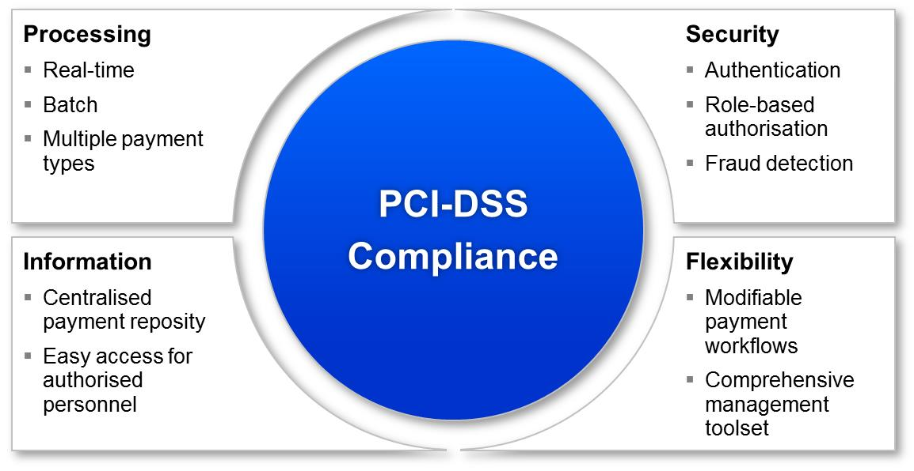

C-PAY's off-the-shelf functionality replaces the majority of development effort required to automate payment processing and provides a flexible base for the easy addition of new payment channels and banking interfaces.

By removing many manual processes, C-PAY greatly reduces the on-going cost of payments processing and by being independent of the banking interfaces, allowing businesses to easily change transaction processing arrangements as they desire.

Developed in Australia over a period of several years with the input of numerous developers, business analysts and operational contact-centre staff; C-PAY brings commercially available, shrink-wrapped and warranted software to the once development-intensive area of payments processing automation.

**C-PAY Benefits Summary**

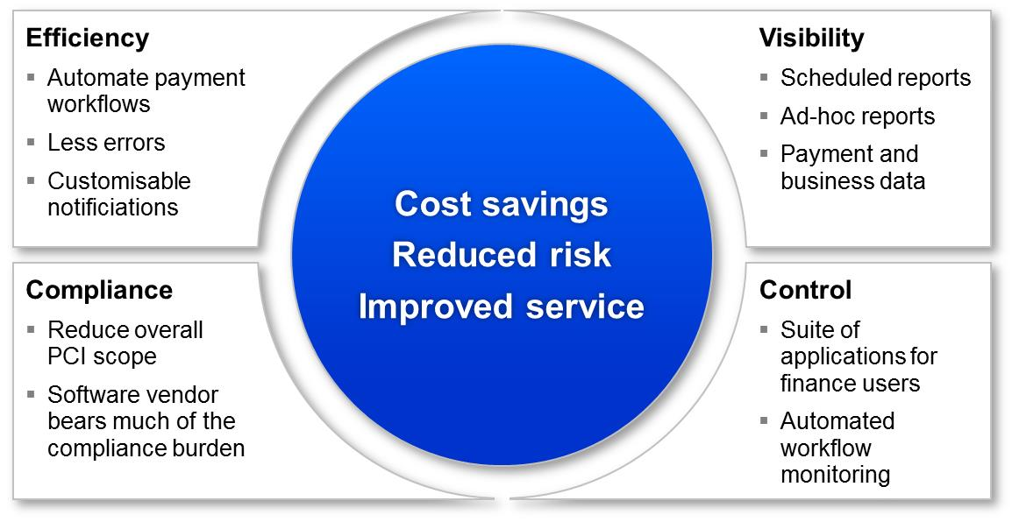

## Tab 3 – Hosting Services

Astor Technology (in a JV partnership with a leading Australian hosting services provider) will soon be offering a full service hosting facility for both essential and innovative applications used by Financial Institutions. The service will provide for high availability, scalability, and security to meet the most stringent requirements of any Financial Institution, large or small.

Our hosting systems are located in premium data centres in Polaris (Brisbane) and Canberra and are certified by the Australian Signals Directorate to PROTECTED level. This is one of only a handful of Australian service providers to have achieved this standard of security accreditation. Key business considerations for our Financial Institution clients include:

**Premium Australian facilities**

Our hosting service is housed in the best data centres in Australia. Tier 3+ rating, ASIO T4 security certified. Interconnected by dark-fibre for dual-active capability and real-time backup. All services are onshore located.

**Gateway certification**

Our service maintains PROTECTED level gateways certified by the ASD at its data centres to satisfy the mandate of Federal Government institutions. This higher level of monitoring and control brings benefits to all Financial Institution clients.

**Service Level Agreement**

Our SLAs are clear, fair and meaningful. They are customised to fit a Financial Institution’s need for guaranteed uptime, response, performance and other critical parameters. We will agree on them up-front, monitor them 24/7, and back them financially.

**Privacy Compliance**

All services are compliant with the Australian Privacy Principles, and we have strict internal policies on data handling. The integrity of your data and service is paramount. We can design and deliver services which meet other specific standards such as HIPAA and NESAF.

**Technical depth**

Our full service hosting JV partner has a ten-year heritage in hosting enterprise services and is a seasoned practitioner with the technical depth and experience to match much larger organisations, but at a size which gives us superior agility.

# Button 3: People

## Tab 1 - Duncan Unwin



**General Overview**

Duncan is an experienced IT executive, architect, program and project manager with expertise in complex systems integration, ICT business case development and ICT transformation across the State and federal government, Banking, Insurance, Health and Manufacturing industries. Duncan has executive and general management experience (IT Manager, CIO, and GM) combined with extensive experience in senior enterprise architecture and program management roles. Duncan’s primary area of focus is IT-enabled business change and ICT transformation. He combines analytical skills together with interpersonal competencies required for effective consulting and change leadership and has particular abilities and experience.

## Tab 2 - Rush Kuntal



**General Overview**

Rush has Double Masters in Information Systems and Information Technology from Griffith University. Rush is an entrepreneur who is involved with Astor Technology in a sales capacity where he is part of the core team that has brought this company to fruition and is responsible for its progression. Rush has also served as a Co-Founder/Director for Peekd Productions, which is an up and coming Mobile Application Development company. Previously has worked with Griffith University as a Residential Advisor where he has years of experience in working with clients from various nationalities and backgrounds. I has also worked with Roger David (Australia) where he has continuously established various sales records and gathered numerous awards in recognition for his work. Serving businesses through innovation, helping them grow & succeed and making a difference in the community by fostering leading-edge IT solutions is something Rush is passionate about.

## Tab 3 - Dr Kim Elms



**General Overview**

Kim has extensive experience in technology start-ups as both CTO and CEO and an extensive network of high-level contacts in the technology sector globally. His knowledge of technology trends is encyclopaedic and has time and time demonstrated the ability to distil complex business problems into sophisticated technology solutions. Kim has more than fifteen years of technology research and development industry experience – both domestically in research and industry companies, as well as internationally through EU-FP6 large integrated projects and multi-national collaboration projects. He has previously held the position of Research Program Manager with SAP Research, the global research division of SAP AG, the German-based enterprise software computer company with such international clients as Nestlé, Lufthansa, Pepsi and Coca Cola. In this position he built a research program – Enterprise Services and Semantics – from three researchers into a program this involved three sites and twelve researchers, while progressing many technologies and initiatives from research projects through to prototype development and then through to commercialization into sections of the SAP product.

## Tab 4 - Warren Shaw

## 

**General Overview**

With over 30 years’ experience in IT servicing Supply Chain Management, Financial Institutions, Payments & e-Commerce on a global basis, Warren has built an enviable career in sales, business development, and executive management roles.

By way of example, Warren worked in partnership with MasterCard starting in 2000 to establish and build a new “white label” payment processing service for card-not-present transactions. His passionate work continued on this project for many years helping to establish channel partners, business processes, and bank implementation methodology while helping to bring more and more financial institutions onto the service. Today, the service operates with over 100 Financial Institutions and 40,000 merchants. Warren has worked on numerous strategic projects with American Express on a global basis and Tier 1 financial institutions such as HSBC, Citibank, CBA, ANZ, and Standard Chartered Bank. These projects have extended to payment processing implementations in large Enterprises with mission critical transaction processing environments including airlines, media, and entertainment.

# Button 4: Services

Astor Technology provides essential and innovative IT services and solutions to Financial Institutions and Enterprises engaged in complex customer payment processes. Our services span the following categories:

* Systems Integration
* Project delivery (including but not limited to management of technical work)
* Sales and support of flexible workflow and integration software to enable customer service innovation, productivity gains, and reduced IT costs
* Technical Consultancy
* Payment software solutions for processing, middleware/integration, reconciliation and reporting
* Hosting Services for Financial Institutions (high availability, scalability, and security)

~~Button 5: CLIENT HUB~~

## ~~Tab 1 - How we can give you the edge in your business (Ask us)~~

## ~~Tab 2 - Request Demos~~

Button 5: CONTACT

* Brisbane office address with phone number and email
* Contact form